BANK LOAN DASHBOARD QUERIES

1. Total Applications

select count(id) as Total_Applications from bank_loan;

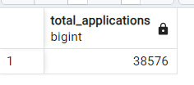

1. MTD Loan Applications

select count(id) as Total_Applications from bank_loan where extract(month from issue_date) = 12;

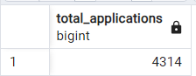

1. PMTD Loan Applications

select count(id) as PMTD from bank_loan where extract(month from issue_date) = 11;

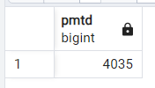

1. Total Funded Amount

select sum(loan_amount) as Total_funded_amount from bank_loan;

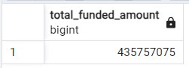

1. This Month Funded Amount

select sum(loan_amount) as MTD from bank_loan where extract(month from issue_date) = 12;

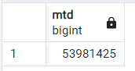

1. Previous Month Funded Amount

select sum(loan_amount) as PMTD from bank_loan where extract(month from issue_date) = 11;

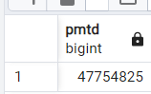

1. Total Amount Received

select sum(total_payment) as Total_Amount_collected from bank_loan;

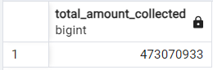

1. Total amount received last month

select sum(total_payment) as Total_Amount_collected from bank_loan where extract(month from issue_date)= 12;

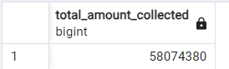

1. Total Amount Received Previous Month

select sum(total_payment) as Total_Amount_collected from bank_loan where extract(month from issue_date)= 11;

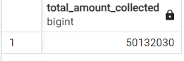

1. Avg Interest Rate

select avg(int_rate)*100 as avg_int_rate from bank_loan;

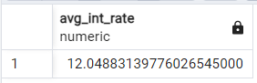

1. MTD Avg Interest Rate

select avg(int_rate)*100 as MTD_avg_int_rate from bank_loan where extract(month from issue_date)= 12;

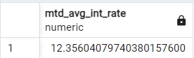

1. PMTD Avg Interest Rate

select avg(int_rate)*100 as PMTD_avg_int_rate from bank_loan where extract(month from issue_date)= 11;

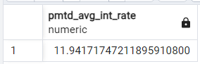

1. Avg DTI

select avg(dti)*100 as avg_dti from bank_loan;

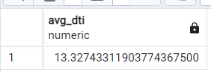

1. LM Avg dti

select avg(dti)*100 as avg_dti from bank_loan where extract(month from issue_date)=12;

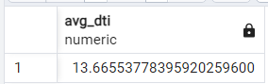

1. PM Avg dti

select avg(dti)*100 as avg_dti from bank_loan where extract(month from issue_date)=11;

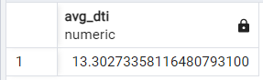

1. Good Loan Percentage

SELECT

(COUNT(CASE WHEN loan_status = 'Fully Paid' OR loan_status = 'Current' THEN id END) * 100.0) /

COUNT(id) AS Good_Loan_Percentage

FROM bank_loan;

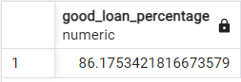

1. Good Loan Applications

SELECT COUNT(id) AS Good_Loan_Applications FROM bank_loan

WHERE loan_status = 'Fully Paid' OR loan_status = 'Current';

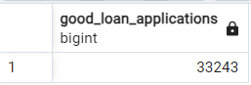

1. Good Loan Funded Amount

SELECT SUM(loan_amount) AS Good_Loan_Funded_amount FROM bank_loan

WHERE loan_status = 'Fully Paid' OR loan_status = 'Current';

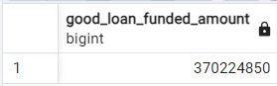

1. Good Loan Amount Received

SELECT SUM(total_payment) AS Good_Loan_amount_received FROM bank_loan

WHERE loan_status = 'Fully Paid' OR loan_status = 'Current';

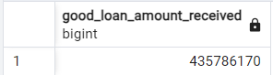

1. Bad Loan Percentage

SELECT

(COUNT(CASE WHEN loan_status = 'Charged Off' THEN id END) * 100.0) /

COUNT(id) AS Bad_Loan_Percentage

FROM bank_loan;

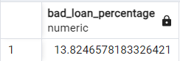

1. Bad Loan Applications

SELECT COUNT(id) AS Bad_Loan_Applications FROM bank_loan

WHERE loan_status = 'Charged Off'

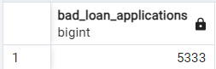

1. Bank Loan Funded Amount

SELECT SUM(loan_amount) AS Bad_Loan_Funded_amount FROM bank_loan

WHERE loan_status = 'Charged Off';

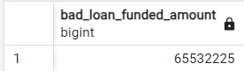

1. Bad Loan Amount Received

SELECT SUM(total_payment) AS Bad_Loan_amount_received FROM bank_loan

WHERE loan_status = 'Charged Off'

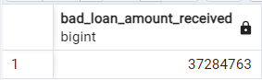

1. Loan Status

SELECT

loan_status,

COUNT(id) AS LoanCount,

SUM(total_payment) AS Total_Amount_Received,

SUM(loan_amount) AS Total_Funded_Amount,

AVG(int_rate * 100) AS Interest_Rate,

AVG(dti * 100) AS DTI

FROM

bank_loan

GROUP BY

loan_status;

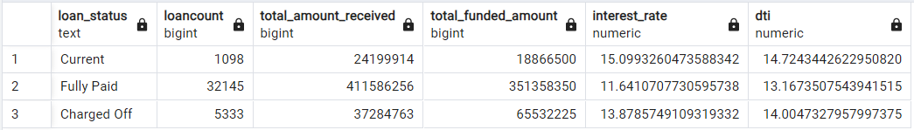

1. MTD Loan Status

SELECT

loan_status,

SUM(total_payment) AS MTD_Total_Amount_Received,

SUM(loan_amount) AS MTD_Total_Funded_Amount

FROM bank_loan

WHERE extract(MONTH from issue_date) = 12

GROUP BY loan_status;

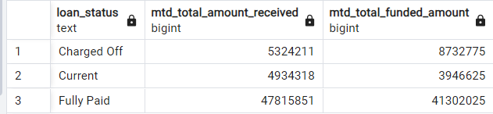

1. Bank Loan Month wise

SELECT

EXTRACT(MONTH FROM issue_date) AS Month_Number,

TO_CHAR(issue_date, 'Month') AS Month_Name,

COUNT(id) AS Total_Loan_Applications,

SUM(loan_amount) AS Total_Funded_Amount,

SUM(total_payment) AS Total_Amount_Received

FROM bank_loan

GROUP BY EXTRACT(MONTH FROM issue_date), TO_CHAR(issue_date, 'Month')

ORDER BY EXTRACT(MONTH FROM issue_date);

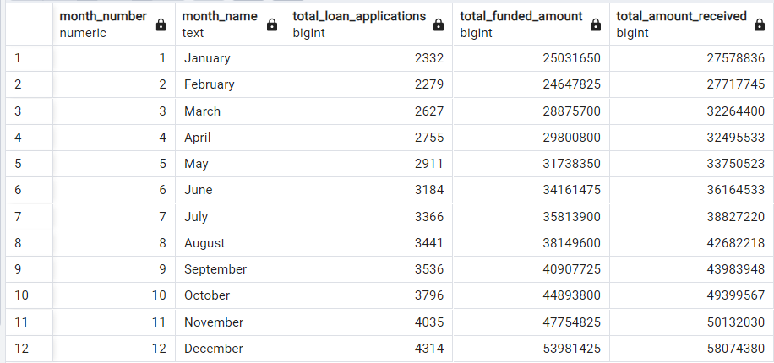

1. State wise

SELECT

address_state AS State,

COUNT(id) AS Total_Loan_Applications,

SUM(loan_amount) AS Total_Funded_Amount,

SUM(total_payment) AS Total_Amount_Received

FROM bank_loan

GROUP BY address_state

ORDER BY address_state;

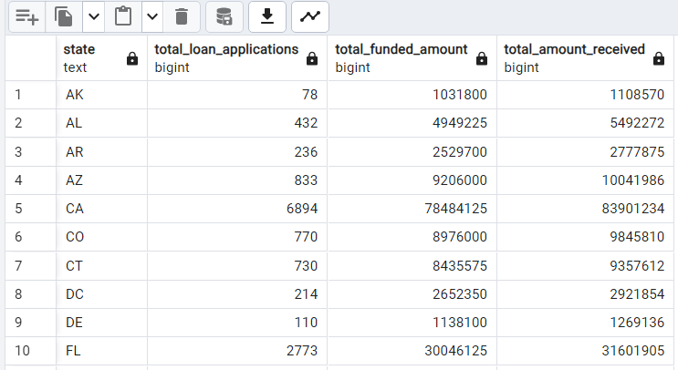

1. Loan Term

SELECT

term AS Term,

COUNT(id) AS Total_Loan_Applications,

SUM(loan_amount) AS Total_Funded_Amount,

SUM(total_payment) AS Total_Amount_Received

FROM bank_loan

GROUP BY term

ORDER BY term

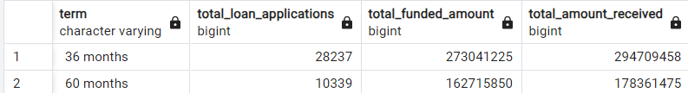

1. Purpose

SELECT

purpose AS PURPOSE,

COUNT(id) AS Total_Loan_Applications,

SUM(loan_amount) AS Total_Funded_Amount,

SUM(total_payment) AS Total_Amount_Received

FROM bank_loan_data

GROUP BY purpose

ORDER BY purpose

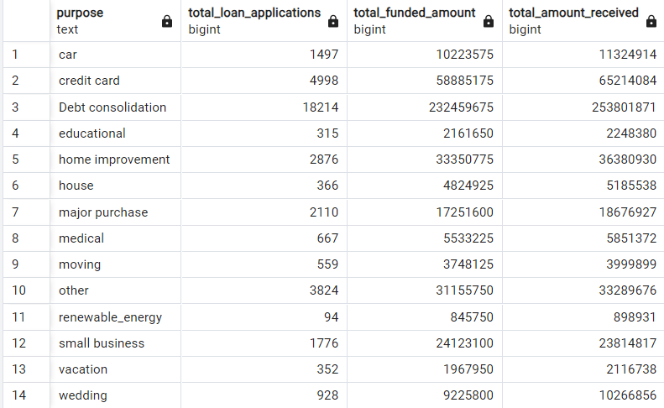

1. Home Ownership

SELECT

home_ownership AS Home_Ownership,

COUNT(id) AS Total_Loan_Applications,

SUM(loan_amount) AS Total_Funded_Amount,

SUM(total_payment) AS Total_Amount_Received

FROM bank_loan

GROUP BY home_ownership

ORDER BY home_ownership

